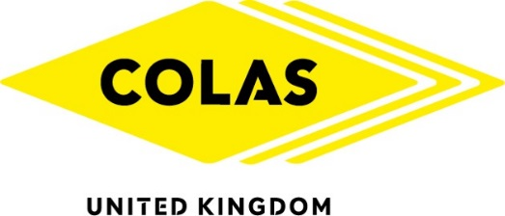

Colas drives forward with M62 safety improvements

Backed by Highways England and Leeds city council, Colas is driving forward with safety improvements on the M62 south of Leeds.
Colas has already begun work on phase one of the project, but the second phase, which will last for 42 weeks, will widen and extend slip-roads at the Tinsley junction 28 – improving safety for the thousands of drivers which use this key route each day.
Increasing road capacity will reduce congestion, as well as improving traffic flows. Commenting on the project, Michael Holmes, Associate Director, Colas Yorkshire, Midlands & North West, said: ‘This latest award compliments the efforts achieved to date on the current M62 Junction 27 project and the strength of collaboration that we have achieved with Leeds City Council and our forward strategic partner in Highways England.’
The award of the second contract underlines the reputation, competence and expertise of Colas and looks set to lead to further contracts in the region. Mr Holmes added: ‘The confidence this has forged between parties is opening other opportunities with potential forward works on the M62 & M621 throughout the latter stages of 2019.’

Notes for Editors

- Colas Limited is a wholly owned subsidiary of French parent group, Colas SA, and is a specialist in road construction and maintenance.

- The award of the second contract is within the Leeds Highway Works Term Contract.

