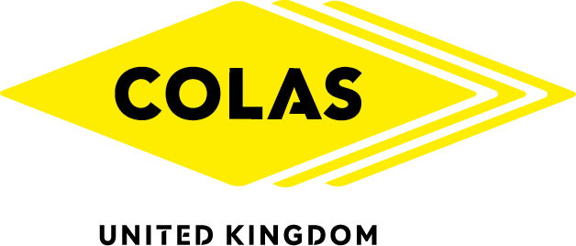
NEW CEO PUTS COLAS ON MULTI-MILLION POUND COURSE FOR TOP TIER
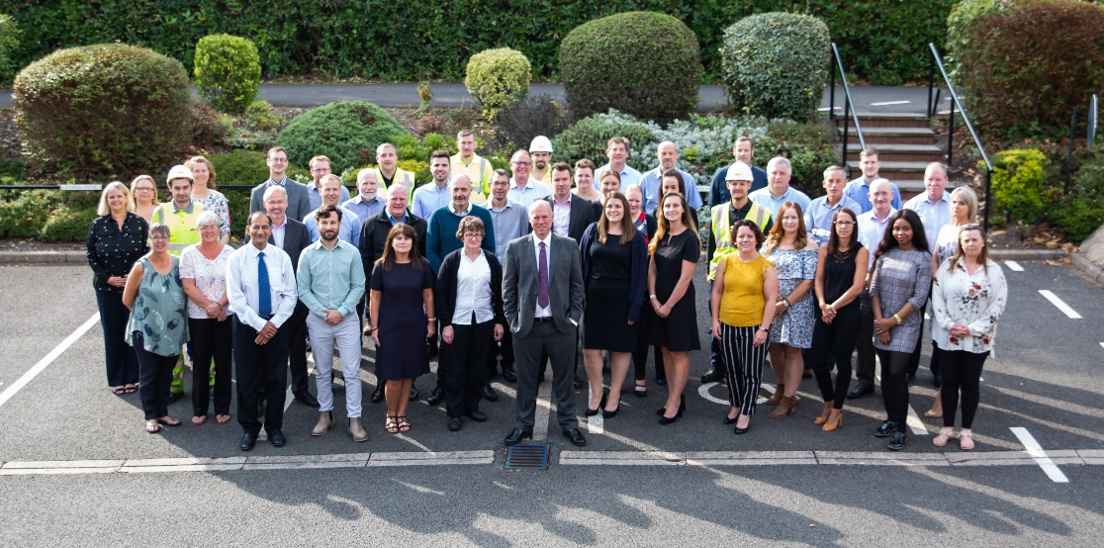

CARL Fergusson, 55, has this week become the new Chief Executive of Colas Ltd - with a mission to ‘wake the sleeping giant’, harness the 95-year old firm’s potential and transform it into a British household name.
The appointment of Mr Fergusson is in keeping with the policy of Colas SA, the firm’s French parent, which invariably draws top personnel from its own ranks, and underlines confidence in the UK business.
In turn, Mr Fergusson will be encouraging innovation and entrepreneurialism across the business, whilst bringing the global group’s drive, know-how and productivity to the UK construction market.
Under Mr Fergusson, Colas Ltd will grow organically and by acquisition, as it competes for large-scale projects at home and abroad - while continuing to deliver its customary high-quality existing portfolio of traditional activities. He said: ‘I am honoured to have been appointed to lead Colas in the UK at this time of significant change in the industry. We will be building on our success, which will mean embracing transformation and change. My mission over the next few years is to awaken the sleeping giant and steer Colas and the people that work here to realise our full potential.
In a personal letter to 1,600 staff, Mr Fergusson, wrote: ‘I have spent 30 years, most of my career, working in the Colas Ltd business and I am very proud of our history and what we have achieved to date...
He emphasised: ‘Our traditional activities and values will remain at the core of what we do, but we must respond with agility to the changing marketplace, the risks and the opportunities that this presents, whilst putting our people at the centre of the transformation journey.’
Mr Fergusson added: ‘We have all heard the adage that it’s not the strongest that survives, but the ones most responsive to change....to stand still, not to change, is equivalent to going backwards in our rapidly evolving market place.’

Notes for Editors
- Carl Fergusson joined Colas in 1989 and has held various management posts during this time, most recently he headed a major strategic review. He replaces Lee Rushbrooke as CEO. Mr Rushbrooke, who is remaining within the wider group at Colas SA’s North American operation, was CEO for seven years.
- Colas SA is a Euro 11.7 billion French-owned global infrastructure construction giant – see Colas SA website for more details.
- Colas Ltd has 1,600 members of staff at 20 sites around the country. The company headquarters is in Rowfant, Sussex, near Crawley and Gatwick.
- Among recent high-profile projects undertaken by Colas Ltd are: a refurbished runway for Airbus Industrie at its Cheshire site; several key marine infrastructure projects at Portsmouth dockyard and the complete infrastructure at a new airport in Uganda. See the website here for more details.
- Please see photograph attached of Mr Fergusson with head office staff on his first day as CEO
For further information please contact the press office on 01342 711 000 or 01342 711 136 and email on sarah.whitebloom@colas.co.uk

{LINK_TO_UNSUBSCRIBE}

